Dear Friends of Saint Charles Caritas, Charity on the Border:

THANK YOU SO MUCH, LORD JESUS CHRIST!

The children,elderly, nuns and volunteers would like to wish you all a wonderful Christmas with love, peace, joy, prosperity and most of all good health to each one of you! "Thank you so much for your continuous love for us, and we love you too!"

Pictures 1 to 6: (1.) Casa de Cuna (orphanage/disadvantaged children) not all 75 children in the picture, (2.) Santa Teresita (home for girls) 55 children, (3.) Casa Eudes (home for girls) 32 kids, (not all in the picture) (4.) Asilo Juan Pablo (home for the elderly) 19 elderly, (5.) Madre Rita, Home for Single Mothers (with 3 volunteers) 19 mothers & 22 children, not all in the picture, and (6.) nuns from TJ representing their charity institutions at St. Charles Church.

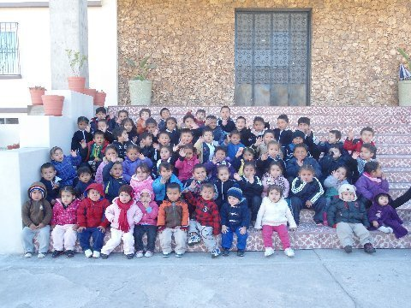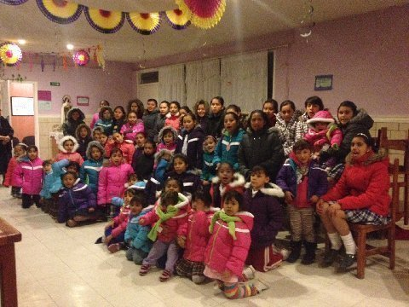

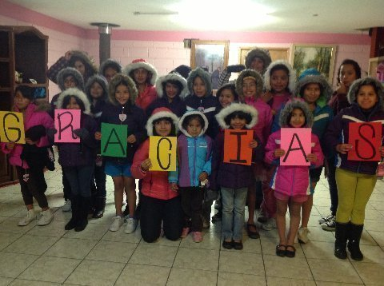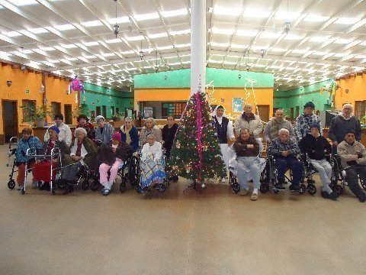

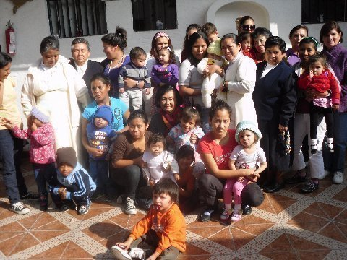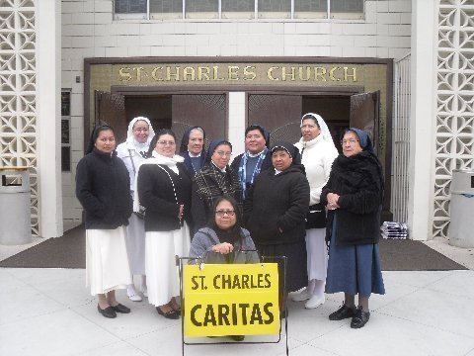

Sincerely yours,
Merlyn Baker
Saint Charles Caritas
Imperial Beach/South San Diego
990 Saturn Blvd.
San Diego, CA 92154
tel# (619) 428-0199
mbaker2020@aol.com
www.saintcharles.org
http://saintcharles.org/st-charles-caritas/

