Dear Friends of Saint Charles Caritas, Charity on the Border:

God is wonderful towards the poor and destitute people!

December 28, Saturday at 8:30am. You are invited to join us for the rosary prayer in English and Spanish. This prayer will be dedicated to all the parishioners of St. Charles Church, volunteers & donors of Saint Charles Caritas, sick people on the prayer list of the church bulletin and your dear families and friends of the Caritas.

The participants will all receive a hand made rosary and prayer pamphlet in English or Spanish on " How to pray the rosary". The nuns from 5 TJ charities will be there and volunteers.

If you want your loved ones to be included in this prayer, please send me an email. All names will be recited in between the decade prayers. We will separate the individuals that you want to be prayed in the following categories:

Thanksgiving please place "TG" after their names
Good Health = "GH"
Sick = "S"
Deceased = "+"

On the same day after the rosary prayer is the Costco buy of food for the 5 charities from TJ at 10:30am.

December 14, 2013, Saturday. The Caritas received more bags of slightly used jackets from the Mission de Alcala Social Action Committee from the organizer, Ms. Anne-Marie Roach. Thank you so much!

Today also is the Project "Homeless in December". Sarah Bajo Warren on behalf of Saint Charles Caritas purchased and bagged 50 bags of food. In each bag are 10 pop top canned food items. Aside from the grocery bags of food other items distributed were brand new wool blankets, cotton gloves, used jackets and rosaries & how to pray the rosary, if they want them. Joe Bajo and Sarah distributed these items in different areas in the South Bay Parks for the homeless: Imperial Beach, Oxford & 3rd Ave, Chula Vista, National City & Home Depot near St. Charles Church. I met the two good hearted people Sarah & Joe in the church for a short time for a briefing. I could not be there for distribution because I have to take care of Jim. I took 5 bags of food, blankets & gloves for distribution when I see homeless pushing carts for distribution.

Please see pictures taking by Joe & Sarah for Project Homeless in December.

Thank you so much Joe & Sarah. Great Job!!!
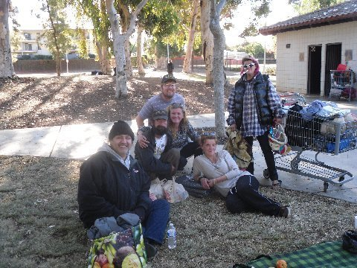

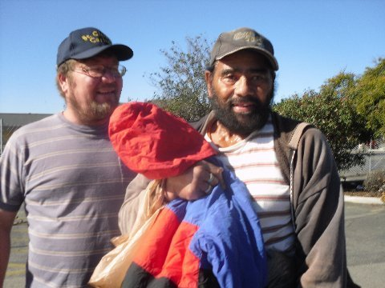

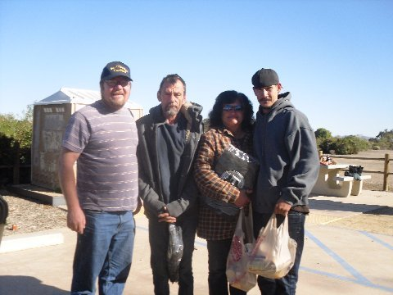

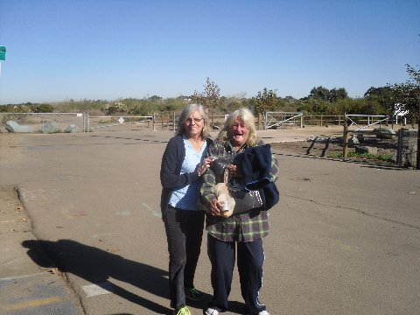

Sincerely,
Merlyn Baker
Saint Charles Caritas
Imperial Beach/South San Diego
990 Saturn Blvd.
San Diego, CA 92154
tel# (619) 428-0199
mbaker2020@aol.com
www.saintcharles.org
http://saintcharles.org/st-charles-caritas/

